**Hotel Management System**

**Developed by: Ronaldo**

**Languages used to create this app are:**

HTML

CSS

JavaScript

MySql

**Tools used to create this app are:**

VSCode Text Editor

Chroome Browser

Xammp Server (LocalHost)

**Package Manager:**

NPM

**Project Structure:**

This project is divided in to two parts.

1. Client, For Client to check their details
2. Admin, For Admin to input new entries

**Directory Structure:**

There are three main directories in this project

1. Airbnb

This directory is for client user where a client can visit and login to their account to see details

1. Airbnb-Admin

This directory is for Admin user where an admin can login to web app and add hotels, facilities and do other stuffs

1. Backend

This directory is used for back end coding. Where the node js server is created and also the database connection is also created with MySql Database.

**Client User Screenshots:**

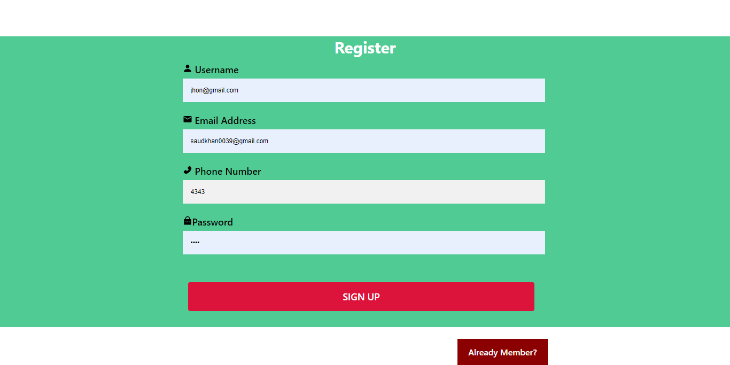Register Screen

Login Screen

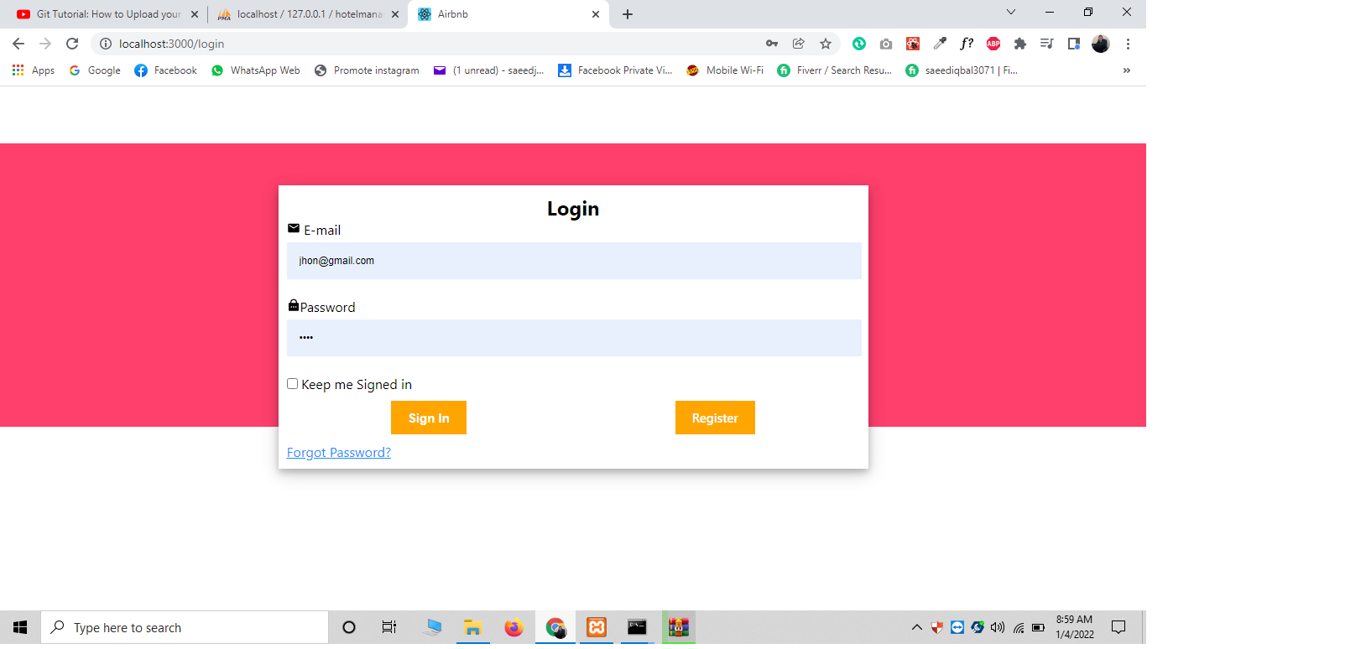

Profile Screen

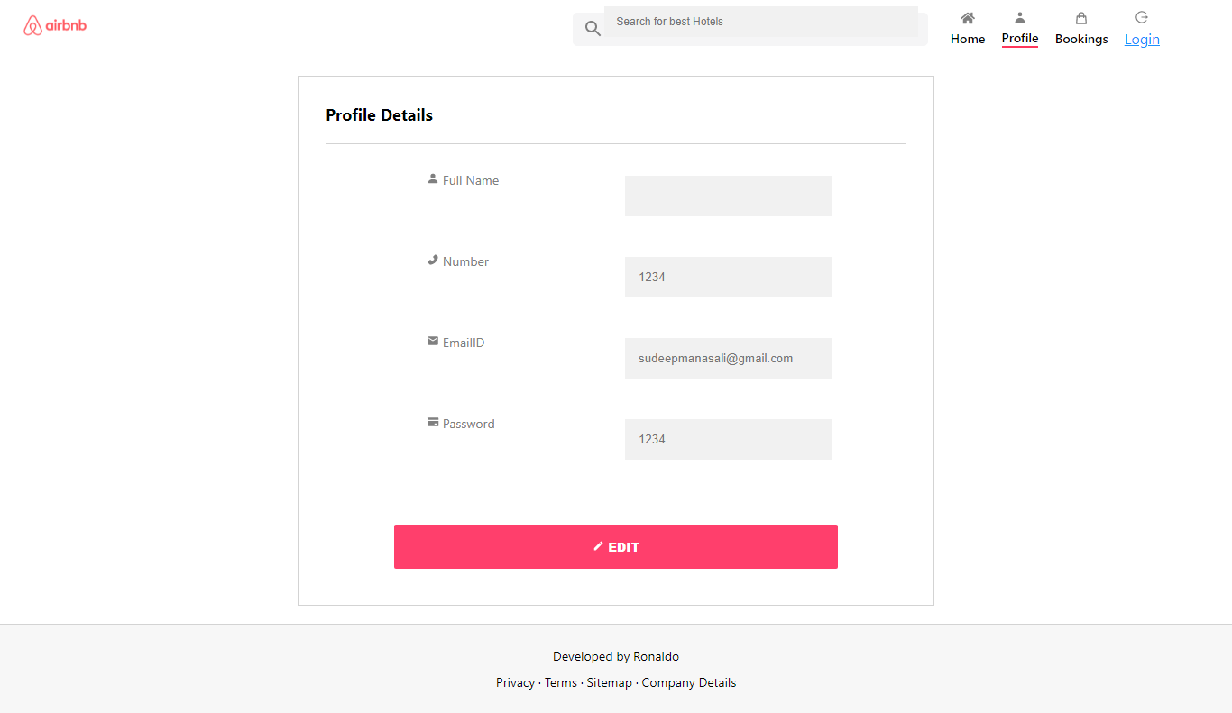

Reservation Screen

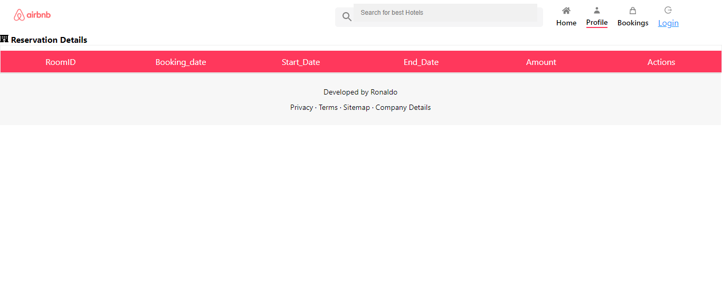

Main Home Screen

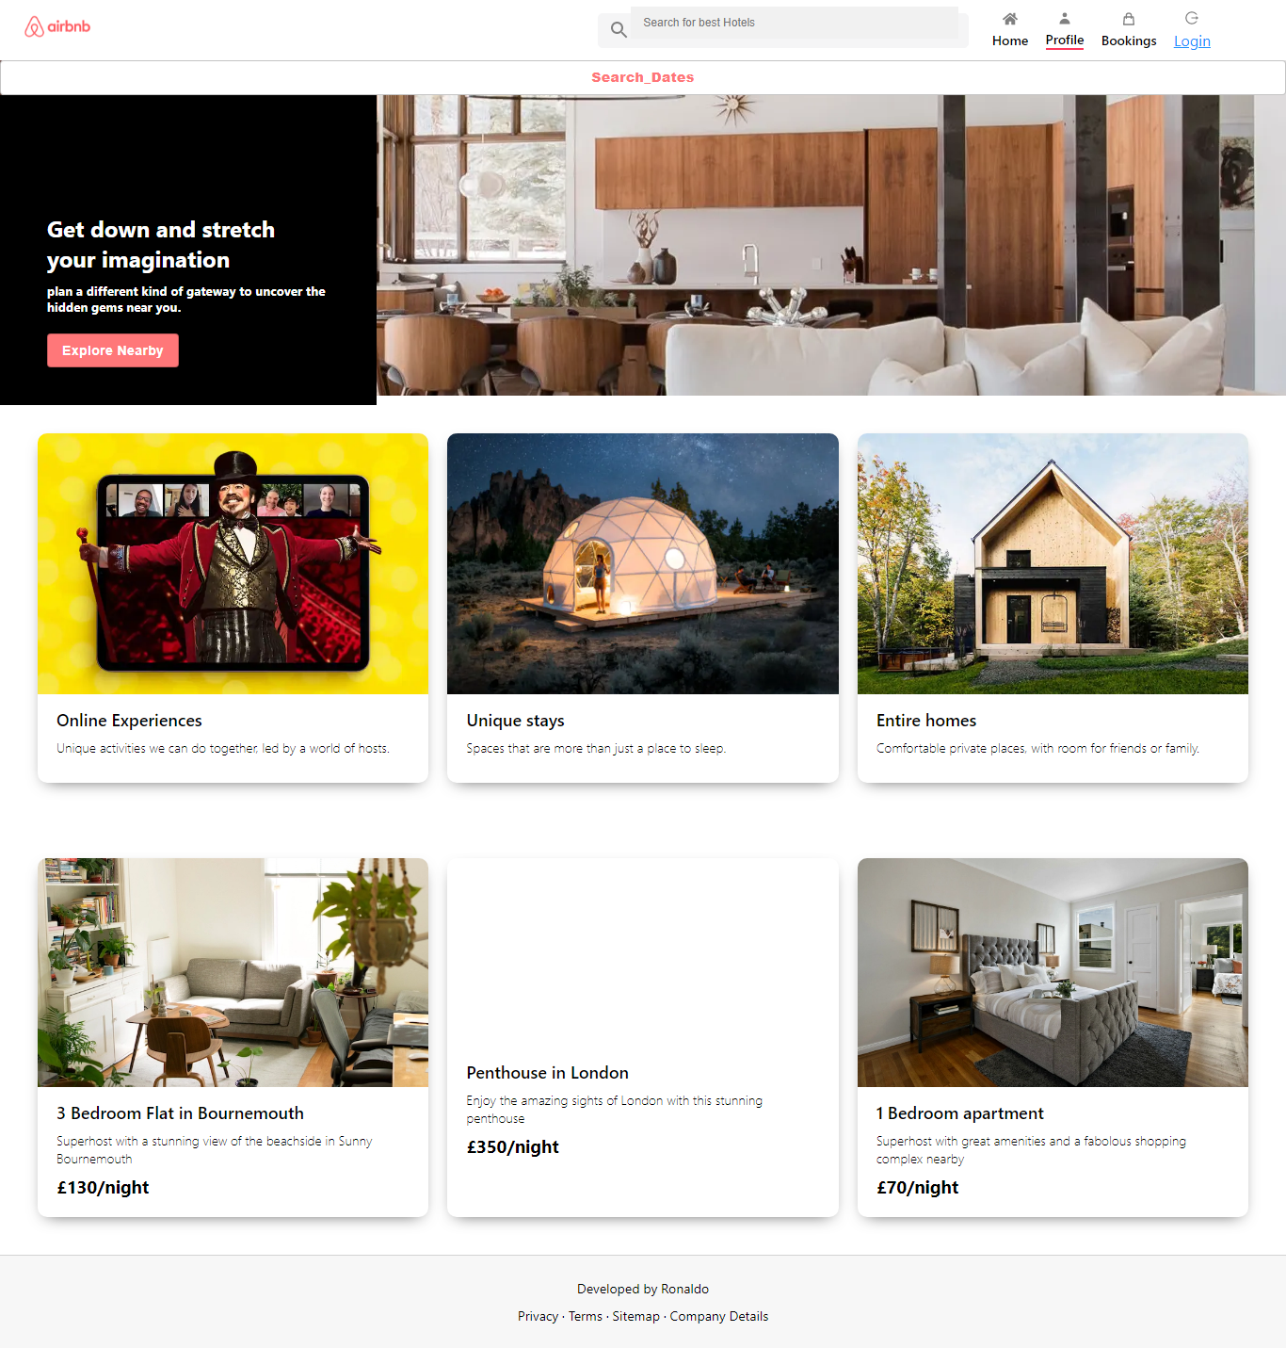

**Explanation of client front end:**

* For the front end development a popular library of JavaScript is used which is known as React JS.
* Inside React JS function based components are used.
* Each element is acting like separate component for example, Menu is considered a single component, Footer, Header, Login etc these are all different separate components
* Each component have 2 files. One is .js JavaScript file while the other is CSS file .css extension.
* CSS is used to make the pages look beautiful and responsive

**Admin User Screenshots:**

Login screen

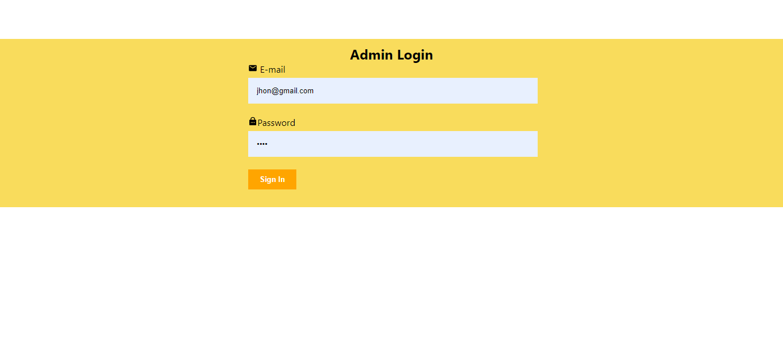

Register Screen



Admin Main Home Screen:

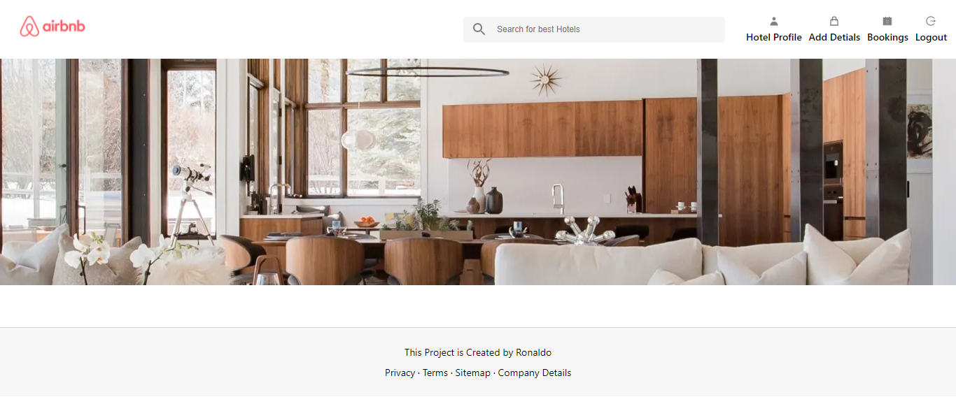

Add Hotels Screen:

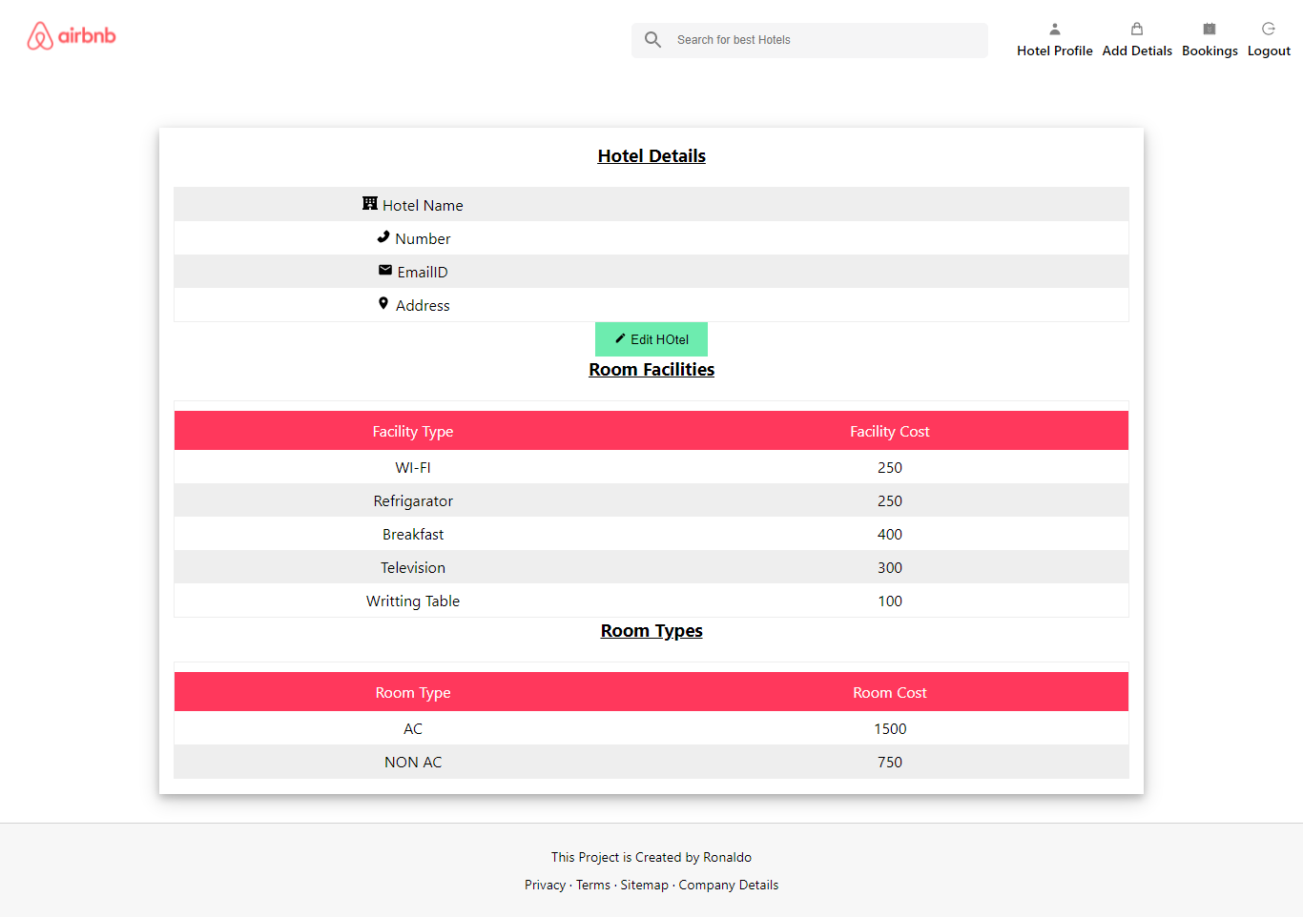

Edit Hotel Details Screen:

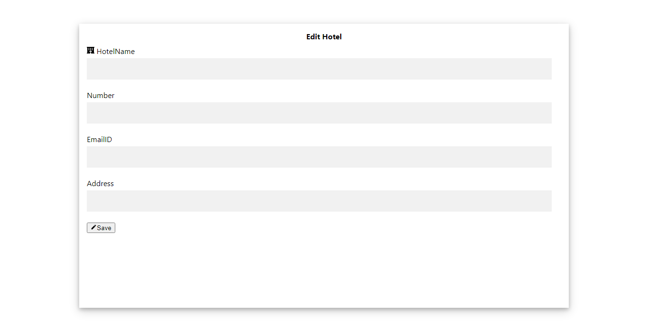

Demo of Hotel Details:

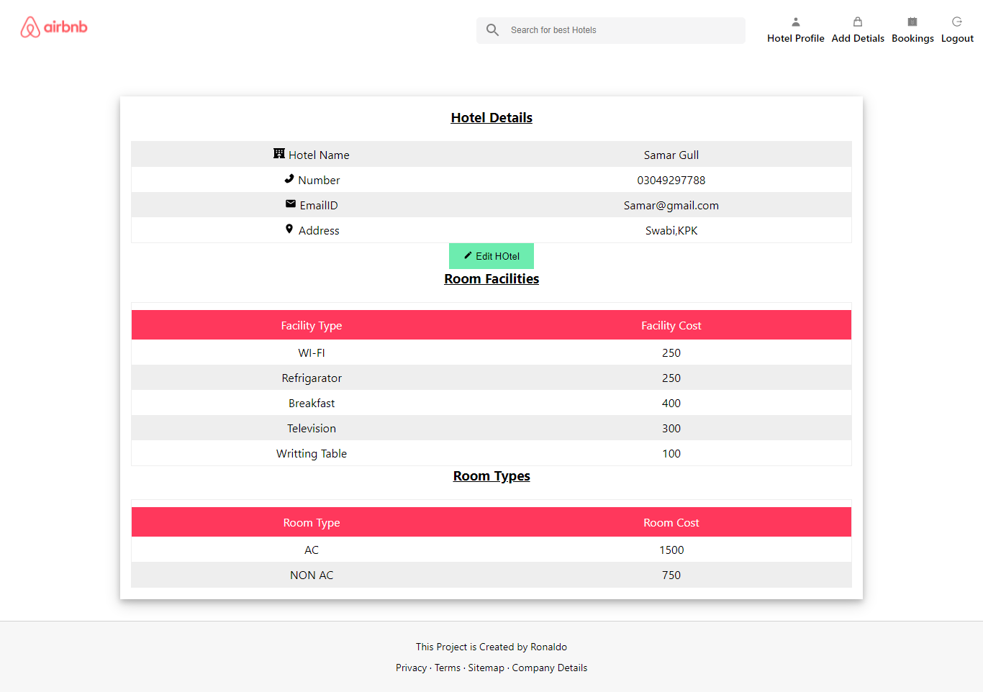

**Explanation of Admin front end:**

* In Admin Section Also, For the front end development a popular library of JavaScript is used which is known as React JS.
* Inside React JS function based components are used.
* Each element is acting like separate component for example, Menu is considered a single component, Footer, Header, Login etc these are all different separate components
* Each component have 2 files. One is .js JavaScript file while the other is CSS file .css extension.
* CSS is used to make the pages look beautiful and responsive

**Backend:**

* For the Back end node js Runtime Environment is used
* Data is parse and fetch in JSON format
* Express JS Framework is used for Server Creation
* For Storing Data MySql Relational Database is used
* Localhost Xammp server is used to create the database

**Package Manager:**

**NPM** Package manager is used to compile the code and run the servers to show the output of the project